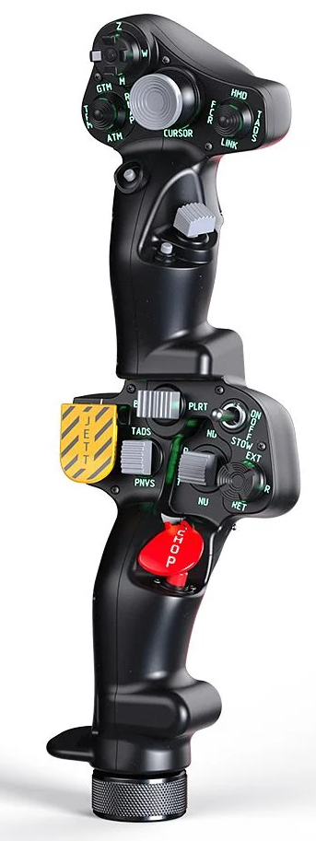  1xx - Controls | 2xx - Ground | 3xx - Flight | 4xx - A2A | 5xx - A2G | 6xx - Misc
102 - Controls - Copilot - Collective Grip Apache-64
U=Up, D=Down, F=Forward, B=Backward, L=Left, R=Right, P=Press, S-*=Shift-*, L-*=Long-*

Top Trigger
- P: Fire Laser
FCR Scan Size hat (top)
- U: MMS FOV Wide / HOG Menu up
- D: MMS FOV Narrow / HOG Menu down
- R: MMS Point Track / HOG Menu confirm
- L: MMS Sensor TV/TIS / HOG Menu back
- P: MMS Frame Freeze/Target Select / HOG Menu on/off
FCR Mode hat (left)
- U: -- (Pilot: SCAS heading hold ENGAGE)
- D: -- (Pilot: SCAS heading hold DISENGAGE)
- R: -- (Pilot: SCAS heading hold RIGHT)
- L: -- (Pilot: SCAS heading hold LEFT)
- P: --
Sight Select hat (right)
- U: NAV Designate / HOG Menu pgup
- D: Target Designate/Locate / HOG Menu pgdn
- L: --
- R: Area Track
- P: --
Cursor hat (Ministick)
- Axes: MMS Slew
- P: MMS Manual/Slave Mode toggle
Cursor Select button (under ministick)
- P: --
FCR Scan switch (thumb) -- Comms
- F: (SRS radio 1 PTT)
- B: (SRS radio 2 PTT)
- P: (VoiceAttack PTT)
- S-P: (VoiceAttack center mouse cursor)
Cued Search button (under thumb switch)
- P: --
Top Pinky button
- P: --
-------------------------------------------------------------------------------------------------------------------------------------
Bottom trigger
- P: --
Boresight rocker
- L: --
- P: --
- R: --
Searchlight switch
- F: -- (Pilot: Searchlight switch ON)
- B: -- (Pilot: Searchlight switch OFF)
- B and Hold: --
Searchlight hat
- U/D/L/R: -- (Pilot: Searchlight up/down/left/right)
- P: --
Jettison button
- P: --
- P and Hold: --
NVS switch
- F: --
- P: --
- B: --
Stabilator switch
- F: -- (Pilot: RPM increase)
- P: --
- B: -- (Pilot: RPM decrease)
Chop button
- P: --
- P and Hold: --
Bottom Pinky button
- P: --

